**CSE102L Computer Programming Lab**

**LAB # 4**



**2020**

**Submitted to:**

**Engr. Abdullah Hamid**

**Submitted by:**

**TAYYABA**

**Registration No :**

**19PWCSE1854**

**Semester: 2nd**

**Class Section:** **C**

“On my honor, as student of University of Engineering and Technology,

I have neither given nor received unauthorized assistance on this

academic work.”

JUNE 8 , 2020

**Department of Computer Systems Engineering**

**University of Engineering and Technology, Peshawar**

**Objectives:**

1. To understand the programming knowledge using Decision Statement “switch”.
2. To understand the programming using for Loop.

**Question No.1**

Write a program to create Simple Calculator using switch case.

**Program:**

**#include<iostream>**

**#include<conio.h>**

**using namespace std;**

**main()**

**{**

**int a,b;**

**char c;**

**cout<<"Select the operator= ";**

**cin>>c;**

**cout<<"Enter Two Numbers using space="<<endl;**

**cin>>a>>b;**

**switch (c)**

**{**

**case '+':**

**cout<<a<<" + "<<b<<" = "<<a+b;**

**break;**

**case '-':**

**cout<<a<<" - "<<b<<" = "<<a-b;**

**break;**

**case '*':**

**cout<<a<<" * "<<b<<" = "<<a*b;**

**break;**

**case '/':**

**cout<<a<<" / "<<b<<" = "<<a/b;**

**break;**

**default:**

**cout<<"Wrong Symbol";**

**}**

**getch();**

**}**

**Output:**

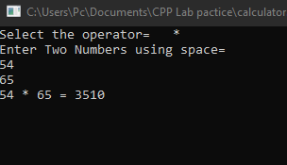

**Question no.2:**

Write a program that takes a number as input, checks it if it is between 1 and 10

(using switch) and if it is in valid range your program should output a line containing

that number of adjacent asterisks. On invalid input number, the program should end.

For example, if your program input is 7, it should print *******.

**Program:**

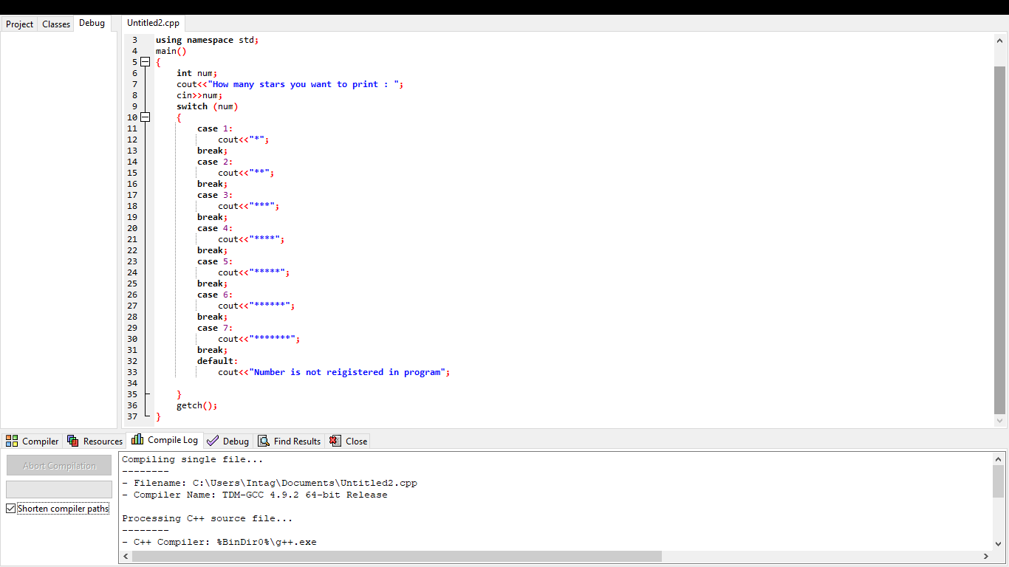**#include<iostream>**

**#include<conio.h>**

**using namespace std;**

**main()**

**{**

**int star;**

**cout<<"How many stars you want to print : ";**

**cin>>star;**

**switch (star)**

**{**

**case 1:**

**cout<<"*";**

**break;**

**case 2:**

**cout<<"**";**

**break;**

**case 3:**

**cout<<"***";**

**break;**

**case 4:**

**cout<<"****";**

**break;**

**case 5:**

**cout<<"*****";**

**break;**

**case 6:**

**cout<<"******";**

**break;**

**case 7:**

**cout<<"*******";**

**break;**

**default:**

**cout<<"Invalid Input";**

**}**

**getch();**

**}**

**Output:**

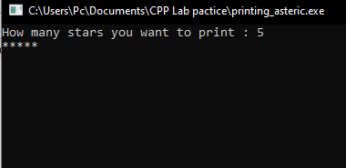

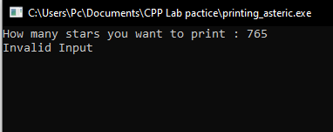

**Question no.3:**

Write a program to find Factorial of a number.

**Program:**

**#include <iostream>**

**#include <conio.h>**

**using namespace std;**

**main()**

**{**

**int j,k;**

**long fact = 1;**

**cout<<"Enter an integer: ";**

**cin>>j;**

**for (k = 1; k <= j; ++k)**

**{**

**fact *= k;**

**}**

**cout<<"Factorial of "<<j<<" is "<<fact;**

**getch();**

**}**

**Output:-**

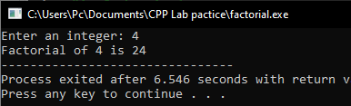

**Question no.4:**

Write a program to print multiplication table of any number.

**Program:**

**#include <iostream>**

**#include <conio.h>**

**using namespace std;**

**main()**

**{**

**int num1,num2;**

**cout<<"Please enter the number of which you to to print a table : ";**

**cin>>num1;**

**for(num2=1;num2<=10;num2++)**

**{**

**cout<<num1<<" * "<<num2<<" = "<<num1*num2<<endl;**

**}**

**getch();**

**}**

**Output:**

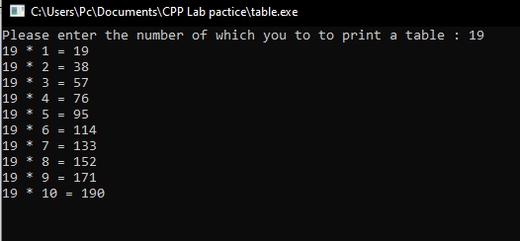

**Question no.5:-**

Write a program to input two integer numbers and display the sum of even numbers

between these two input numbers.

**Program:**

**#include <iostream>**

**#include <conio.h>**

**using namespace std;**

**main()**

**{**

**int num1, num2, sum = 0;**

**cout << "Enter 1st Number: ";**

**cin >> num1;**

**cout << "Enter 2nd Number: ";**

**cin >> num2;**

**while (num1 <= num2)**

**{**

**if(num1%2 == 0)**

**sum += num1;**

**num1++;**

**}**

**cout << "The sum of all even numbers between " << num1 << " and " << num2 << " is " << sum << "." << endl;**

**getch();**

**}**

**Output:**

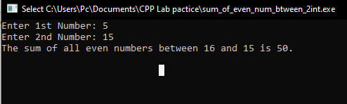

**Question no.6:**

Write a program to print all natural numbers in reverse (from n to 1).

**Program:**

**#include<iostream>**

**#include<conio.h>**

**using namespace std;**

**main()**

**{**

**int n;**

**cout<<"Please enter your no. : ";**

**cin>>n;**

**while (n>=1)**

**{**

**cout<<n<<" .. ";**

**n--;**

**}**

**getch();**

**}**

**Output:**

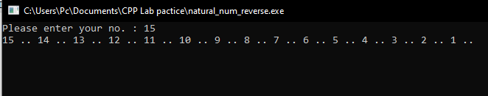

**Question no.7:**

Write a program that takes the base and exponent as input and display the result of

power.

**Program:**

**#include <iostream>**

**#include <conio.h>**

**using namespace std;**

**main()**

**{**

**int exp;**

**float base, result = 1;**

**cout <<"Enter base and exponent respectively: ";**

**cin >>base>>exp;**

**cout <<base<<" ^ "<<exp<< " = ";**

**while (exp != 0)**

**{**

**result *= base;**

**--exp;**

**}**

**cout<<result;**

**getch();**

**}**

**Output:**

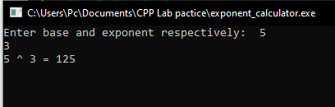

**Question no.8:-**

Write a program to check if a number input by user is PRIME or not.

**Program:**

**#include <iostream>**

**#include<conio.h>**

**using namespace std;**

**int main()**

**{**

**int i;**

**cout << "Enter a number: ";**

**cin >> i;**

**if (i % 2 == 0)**

**{**

**cout << i << " is a prime number";**

**}**

**else{**

**cout << i << " is an odd number";**

**}**

**getch();**

**}**

**Output:**

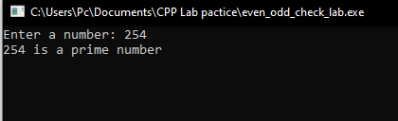

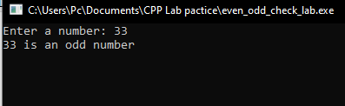

**Question no.9:-**

Write a program to display Fibonacci series up to 200.

Fibonacci series: 0, 1, 1, 2, 3, 5, 8, 13, ….

**Program:**

**#include <iostream>**

**#include <conio.h>**

**using namespace std;**

**main()**

**{**

**int a, t1 = 0, t2 = 1, nextTerm = 0;**

**cout << "Enter the number of terms: ";**

**cin >> a;**

**cout << "Fibonacci Series: ";**

**for (int i = 1; i <= a; ++i)**

**{**

**if(i == 1)**

**{**

**cout << " " << t1;**

**continue;**

**}**

**if(i == 2)**

**{**

**cout << t2 << " ";**

**continue;**

**}**

**nextTerm = t1 + t2;**

**t1 = t2;**

**t2 = nextTerm;**

**cout << nextTerm << " ";**

**}**

**getch();**

**}**

**Output:-**

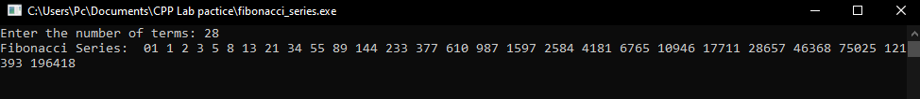

**Question no.10:-**

Write a program to find GCD (greatest common divisor or HCF) and LCM (least

common multiple) of two numbers.

**Program:**

**#include <iostream>**

**#include <conio.h>**

**using namespace std;**

**main()**

**{**

**int a, b, num1, num2, n, gcd, lcm;**

**cout<<"Enter two integers"<<endl;**

**cin>>num1>>num2;**

**a = num1;**

**b = num2;**

**while (b != 0)**

**{**

**n = b;**

**b = a % b;**

**a = n;**

**}**

**gcd = a;**

**lcm = (num1*num2)/gcd;**

**cout<<"Greatest common divisor of "<<num1<<" and "<<num2<<" = "<<gcd<<endl;**

**cout<<"Least common multiple of "<<num1<<" and "<<num2<<" = "<<lcm<<endl;**

**getch();**

**}**

**Output:**

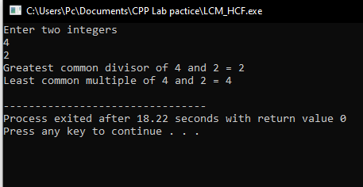

**Question no.11:-**

Write a program that performs a survey tally on beverages. The program should prompt

for the next person until a sentinel value of –1 is entered to terminate the program. Each

person participating in the survey should choose their favorite beverage from the

following list:

1. Coffee 2. Tea 3. Coke 4. Orange Juice.

**Program:**

Sorry sir Not sure about this one.